Certificate Authority with ORM stack

Contents

1. Introduction 2
2. Workflow diagram to deploy the stack 3
3. Create stack for Certificate Authority 4
4. Plan the Job 6

Introduction

A certificate authority (CA) issues digital certificates and manages their revocation. A CA typically contains other CAs with defined parent-child relationships between them. The CA at the top of a hierarchy is known as the root CA. Any CA that is not the root CA is a subordinate CA.

Workflow diagram to deploy the stack

Below diagram shows how the Terraform Artifact are applied in the OCI. While creating a ORM stack, using terraform deliverables Init, Plan and Apply is the flow to provision the resource in the OCI. We can have the deliverables in any of below.

- GitLab/GitHub Repo
- Bitbucket
- Can be in folder/.zip in the local disk
- Object Storage Bucket
- Can be in compartment
- Oracle provided Template

Prerequisite
- Generate Asymmetric key in the vault
- Create IAM Policies

Create stack for Certificate Authority

Go to OCI Console Developer Services Resource Manager Stacks select the compartment Create Stack

My Configuration Folder Browse Select the “Certificate_authority” folder that contains the terraform Upload

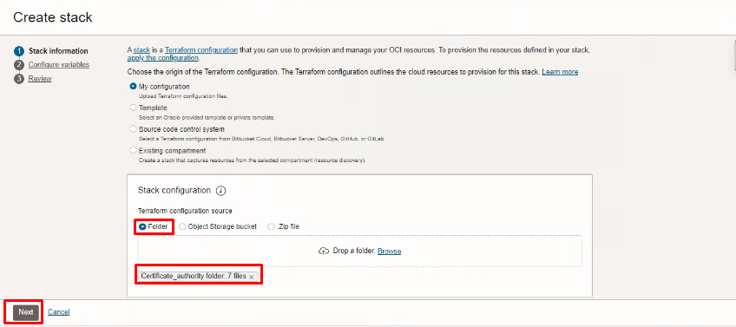

Select the parameters as per the below screen,
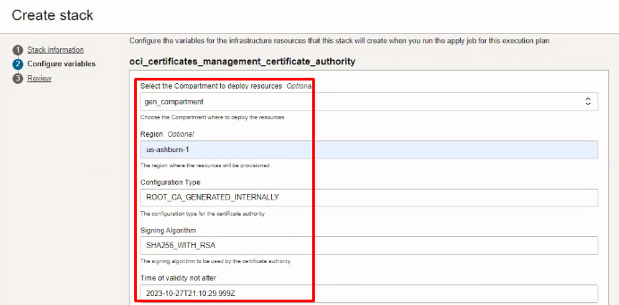

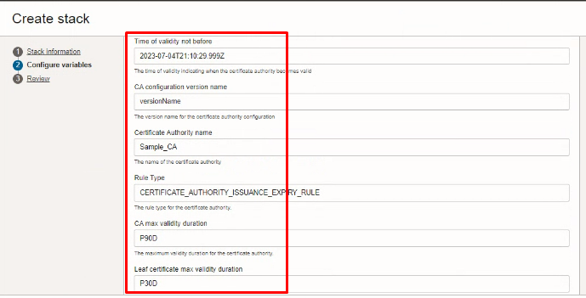
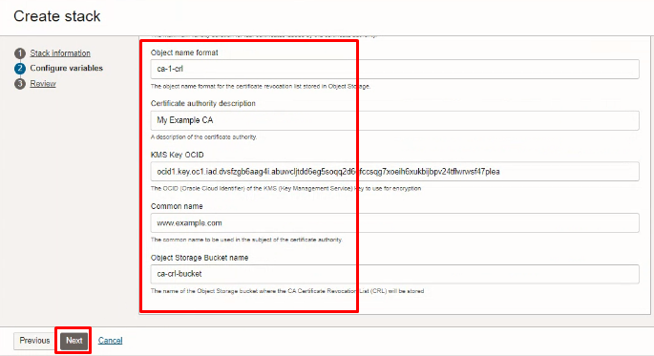
Click “NEXT”
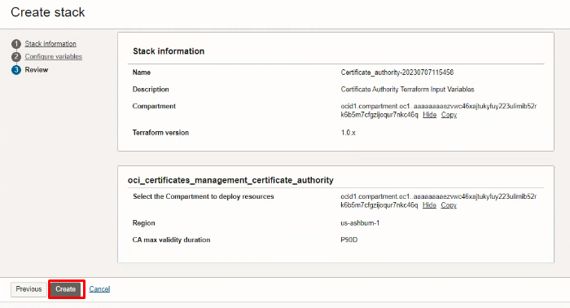
Click “CREATE”

Plan the Job

Click the “Plan”
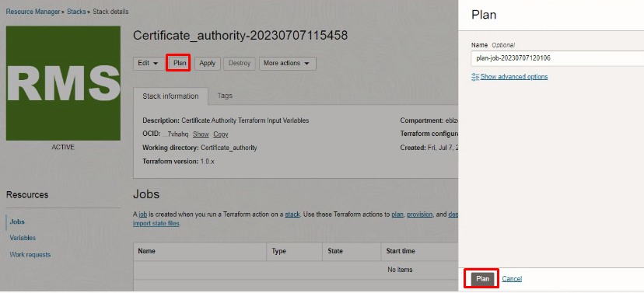

Verify the Plan is successful.

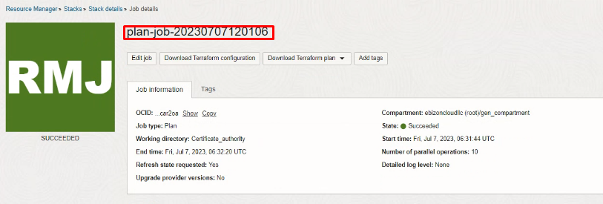
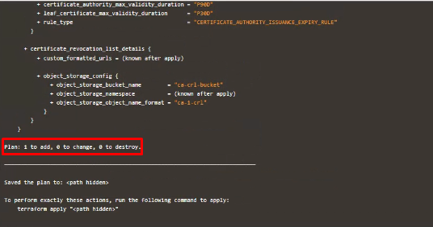

#END#

